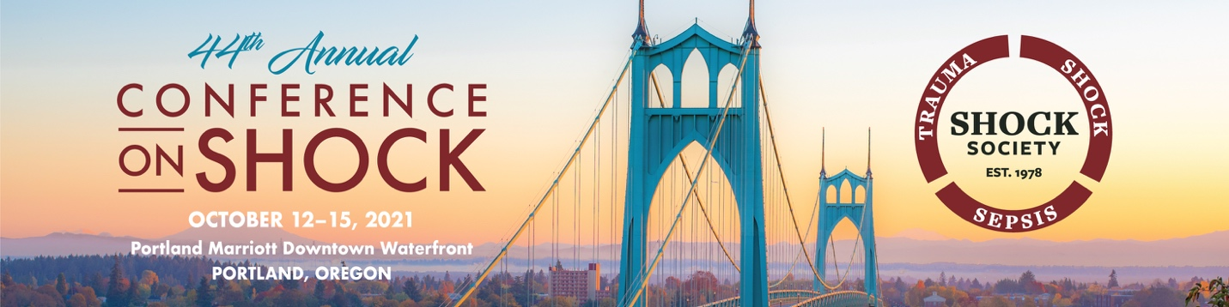

ADVANCE REGISTRATION DEADLINE: September 9, 2021

Please print and submit this form with payment or register on-line at
https://shoso.memberclicks.net/44th-annual-conference

Mail Form to:
Shock Society, 1300 Piccard Drive, Suite LL-14, Rockville, MD, USA 20850
Or email to: shock@shocksociety.org

Name__________________________________________________________________Degree:__________________________

Institution or Company Affiliation: _________________________________________________________________________

Address: _______________________________________________________________________________________________

City:_____________________ State:______________Zipcode:________________Country:___________________________

Telephone: __________________________________________Fax:________________________________________________

Email Address: __________________________________________________________________________________________

Please circle your preferred Pronouns: None He/Him/His She/Her/Her’s They/Them/Theirs

Please circle any Dietary Restrictions: None Gluten Free Kosher Pescatarian Vegetarian

Please list any food allergies: _____________________________________________________________________________________

Registration Fee (payable in U.S. Funds)

Status | Early  Prior to  September 9, 2021 | Advance  September 9 - October 10, 2021 | Onsite  At the Meeting or after October 10th
□ Member | $565 | $615 | $665
□ Non-Member | $810 | $860 | $910
□ Post Graduate Fellow Member | $520 | $570 | $620
□ Student Member | $480 | $480 | $550
□ Lab Technician Member | $550 | $550 | $550
□ Spouse/Guest  (social events only) | $250 | $250 | $300
Spouse/Guest Name: __________________________________________________________
Please select events you are attending below
□ Dinner Ticket – October 15th –Scientific Achievement and Service Awards Ceremony

PAGE 2 – SHOCK SOCIETY 2021 REGISTRATION FORM

Additional Tickets to Purchase | Fee | #Tickets
□Additional Dinner Tickets – October 15th –Scientific Achievement and Service Awards Ceremony | $95

Please click the following link for the Shock Society Annual Conference Policies and Terms before proceeding with your payment:
https://shoso.memberclicks.net/assets/Shock%20Society%20FINAL%20COVID%20Safety%20Disclaimer%20.pdf
□ By checking this box, I agree to the Shock Society 2021Annual Meeting Policies and Terms.
Registration Payment Form – Full payment must accompany your registration form. Check payments must be drawn on U.S. bank in U.S. funds and made payable to The Shock Society with the conference in the memo section of the check.
Total Payment $ ________________________ Select one: □ Visa □ MasterCard □ American Express □ Check
Signature: _____________________________________________________________________________________________________
Your signature authorizes your credit card to be charged for the total payment above.

Print Name: ____________________________________________________________________________________________________
Credit Card # ______________________________________________________ Exp Date: ___________________________________
Registration Cancellation Policy
If you decide to cancel in advance, due to broader closures or changing COVID 19 developments, you may request a refund of your registration fee by contacting Shock’s Executive Director, Serena G. Weisman at sweisman@shocksociety.org and your request will be reviewed by the Executive Officers.
Please contact shock@shocksociety.org with any necessary ADA accommodations.

